- Police Stations
- Ermita Police Station, 1.6 km away
- Manila Police District Ermita, 1.0 km away
- Paco Police Station, 1.8 km away
- No. 5 Police Station, 0.55 km away
- (PS-9) Malate Police Station, 1.5 km away
- Manila Police District (DD’s Place), 1.4 km away
- San Andres Police Community Precinct, 3.7 km away
- SWAT Firing Range Manila Police District, 1.8 km away
- San Andres Police Station, 3.3 km away
- Adriatico Police Community Precinct, 1.6 km away
- MPD Sampaloc Police Station (PS-4), 5.4 km away
- Penafrancia Police Community Precinct, 2.9 km away
- Pasay City Police Station, 2.8 km away
- Pass Control Office, 2.0 km away
- Dagonoy Police Community Precinct, 3.5 km away
- Luneta Park Police Detachment, 1.8 km away
- Pandacan Police Station (PS-10), 4.1 km away
- Makati Police Station, 4.4 km away

- Fire Stations
- Paco Fire Sub-Station, 1.7 km away
- Triskelion Order of Firefighters, Inc., 1.6 km away
- Arroceros Fire Sub Station, 2.5 km away
- Makati Fire Sub Station, 4.4 km away
- Reavo Volunteer Fire Headquarters, 2.9 km away
- Intramuros Fire Sub-station, 2.5 km away
- Santa Ana Fire Station, 3.0 km away
- Bureau of Fire Protection – Makati, 4.1 km away
- Sampaloc Fire Station, 5.4 km away
- San Nicolas Fire Station, 4.5 km away
- Tanduay Fire Station, 4.0 km away
- Pasay Fire Station, 5.2 km away
- Sta. Mesa Fire Station Nr 8, 5.5 km away
- 298 Filipino Chinese Volunteer Fire Brigade, Inc., 3.5 km away
- South San Nicolas Volunteer Fire Brigade, 3.6 km away
- Pandacan Fire and Rescue Volunteer Headquarters, 3.4 km away
- Soler Volunteer Fire Prevention Center and Medical Foundation, 3.8 km away
- Pasay Volunteer Fire Brigade, 4.2 km away
- Arranque Volunteer Fire Brigade, 3.7 km away

- Hospitals
  - Philippine General Hospital, 1.1 km away
  - Manila Doctors Hospital, 1.5 km away
  - Manila Children’s and Lying-In-Hospital, 1.6 km away
  - Accredited OFW Medical Clinics & Hospital, 2.3 km away
  - Security Forces Hospital, 1.7 km away
  - Health District Office V, 2.1 km away
  - Heartland Medical and Diagnostic Center, 2.3 km away
  - Child Haus, 1.6 km away
  - EG Healthcare Inc. Metropolitan Hospital, 2.9 km away
  - Manila Medical Center, 1.4 km away
  - Ospital ng Maynila, 1.4 km away
- Philippine Red Cross
  - Manila Chapter, 2.3 km away
  - Makati Chapter, 4.4 km away
  - Safety Services, 3.0 km away
  - National Blood Chapter, 3.0 km away
  - Pasay Chapter, 6.4 km away

Roles
- Incident Commander
- Operations Head
- Planning
- Logistics
- Liason
- Public Information Officer
- Finance
- Evacuations Head
- Search & Rescue
- Firefighting
- Safety
- Medical

Running time of every scenario is around 30-40 minutes.

COMMAND –

SCENARIO TIMELINE

Time | Source | Information
00:00 | Librarian | - fire broke out at the library, 2nd floor, Rizal Hall  - a whole section was already in flames  - smoke detectors were not working and are scheduled to be fixed the following week  - Chief librarian immediately pulled the fire alarm upon knowing of the incident
00:01 | Security Guards | - students start evacuating the building
00:03 | Firefighting Team | - fire is uncontrollable  - two sections are already in flame
00:05 | Evacuation Team | - people are shouting, crying, and breaking down  - some students fainted  - some students are insisting to leave the area
00:06 | Security Team | - foot traffic building up  - heavy traffic along Padre Faura Street due to commotion
00:06 | Chief Librarian | - centennial books that should be retrieved are inside the library
00:07 | Security Guard | - 325 people were recorded to be inside the building cluster
00:07 | Evacuation Team | - 130 people accounted [110 student (60 F, 50 M), 20 staff and faculty members (8 F, 12 M)]  - current evacuation site can only hold 175 people  - students reported that they heard people were stranded in the second floor
00:07 | BFP | - fire trucks cannot enter P. Faura due to heavy vehicular traffic
00:09 | Evacuation Team | - 12 evacuees were injured
00:10 | Evacuation Team | - additional 100 people accounted [65 students (35 F, 30 M), 35 faculty and staff members (15 F, 20 M)]  - current evacuation site is already crowded  - media personnel arrive at the evacuation site
00:10 | First Aid Team | - request for additional manpower  - request for supplies (5 02, 5 bandages, 7 IV fluid with needle, and 3 blankets)
00:11 | Search and Rescue Team | - asking permission to enter the building
00:12 | Evacuation Team | - 7 evacuees were injured
00:14 | Search and Rescue Team | - request for (3) spine boards and additional (2) SAR teams
00:15 | First Aid Team | - request for ambulance (2) with BLS and (2) with ALS
00:15 | Evacuation Team | - students are still insisting to go home  - a parent is looking for his child (Ennaid Lim, F, 22)
00:18 | Search and Rescue Team | - (3) were rescued from the 2nd floor  - DSS008, M – from Men’s Room  - DSS045, F – Computer Room  - DSS099, M – Computer Room
00:18 | First Aid Team | - request for (4) splints, (2) stift collar, and (20) analgesia
00:19 | Evacuation Team | - additional 70 people arrive [35 students (25 F, 10 M), 35 staff and faculty members (17 F, 18 M)]
00:21 | Evacuation Team | - 2 evacuees were injured
00:24 | Search and Rescue Team | - (2) were rescued from the 2nd floor  - DSS084, M – RH 220  - DSS063, F – Ladies’Room
00:26 | First Aid Team | - request for additional ambulance (2) with BLS  - request for (5) nasopharyngeal tube, and (10) analgesia

COMMUNICATION:

- Designated Incident Commander (IC) out for official business
- Responsible Officer (RO) orders the retrieval of important documents from the University Library

COLLABORATION
- Responsible Officer (RO) orders the retrieval of important documents from the University Library
- ICP is inside the adjacent building when the lights went off due to the fire

GRAND SCENARIO
- The Dean ordered the immediate rescue of the Assistant to the Dean who was reported trapped in room 109
- Centennial books were kept at the library section right above the burning room
- The Head of PNP, upon being notified of the suspicious origin of the fire, wanted to take command
- The BFP Chief insisted to take control since it was a fire incident

TESTED ON October 23, 2025
- Improvements needed
  - Compilation of requested items on the side? To keep track of which items were not yet lent
  - Not all requested items will be delivered immediately. For example:
    - Requested 5 ambulances by 2:00PM
    - First ambulance will be given on 2:10, another by 2:15, another by 2:30 and so on
    - Then in between those, other requested will be made, such as a police team by 2:12
  - The resource request log does not fit, unless zoomed out. Alternatively, pwede kaya na upon clicking the done button ay mag gray out yung entire row?. Nasa dulo pa kasi ang done and not as easy makita if which ones pa ang requests na di pa nabibigay.
  - Sa source category, pwede kaya di strictly dropdown? May items pala na flexible ang sources so hindi na makainput in that case. For example, requesting for food pax. Initial source namin ay PGH dietary but if they request for more, we prompt them if saan source pa na pwede nilang maisip – then whatever sasabihin nila ay yun na ilalagay namin.
  - No need na yung resource set column upon export ng pdf since nakastate naman na sa top. Wala rin masyado na bearing sa evaluation.
  - Not sure what this section does:
    - 
  - Not as readable yung headers sa exported PDF
    - 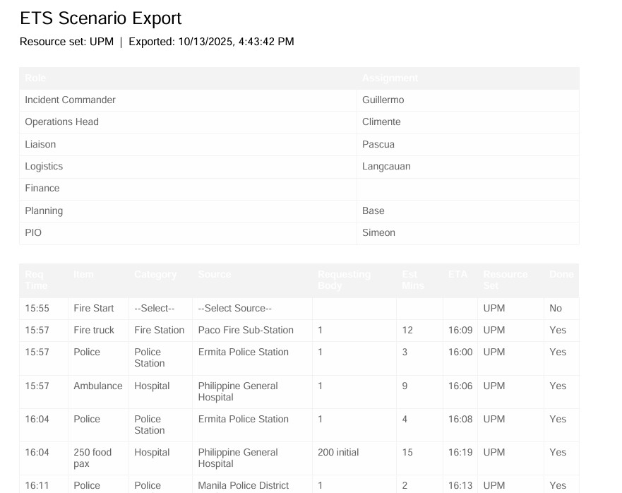
  - Not as effective yung requesting body, can we change it to remarks na lang?
  - Pwede kay may feature na if same time na sa ETA ay magcchange yung color? To alert na time na?
- Good points
  - Delete button was very useful and good addition
  - Maganda yung identify first ang hospital and kung anong specific sources lang ng hospital ang lalabas upon identifying the hospital. Avoids confusion.
  - Maganda yung flexibility ng ETA after adjusting the est. mins
  - I think the grand scenario works well na, need lang more proficiency on the user and adjustments sa interface. Okay na rin siya actually on its own, pwede siyang mareuse na lang sa other scenarios and just indicate whether comms, collab, or grand na sa scenario name para lesser work and we can allot more time in improving than making new pages.
  - I really like yung save and history features
  - Autosave feature

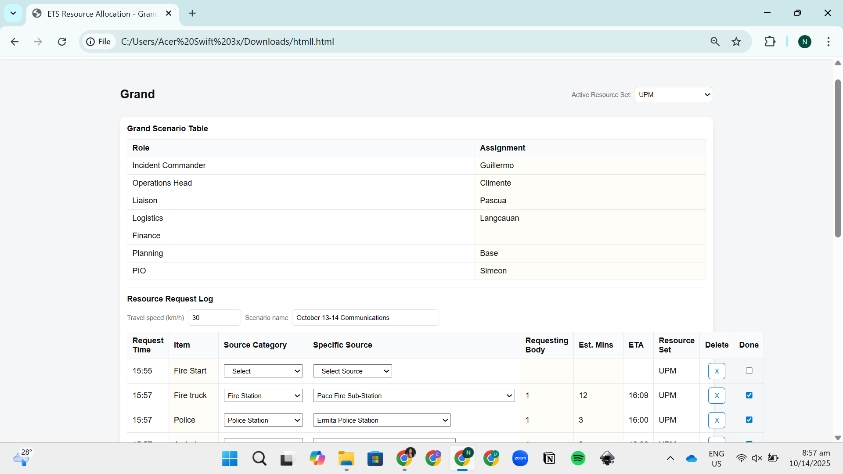

Additional features as of November 9, 2025
- Add incident type: fire, earthquake, flood, typhoon, mass casualty
- Real time dashboard analytics - which will also be reflected sa pdf export
  - Total requests by category
    - Police
    - Fire station
    - Hospital
    - Others
  - Response time comparison
    - Time requested vs actual arrival time of critical resources (fire truck, police team, ambulance, and food) – response time indicator
    - Horizontal timeline chart
    - Each resource—Fire, Police, Ambulance, and Food—is represented by a horizontal bar that starts at the time it was requested and ends at the time it arrived. A vertical dashed line marks the incident start (0 min), allowing you to see both the delay to request and the delay to arrival.
    - 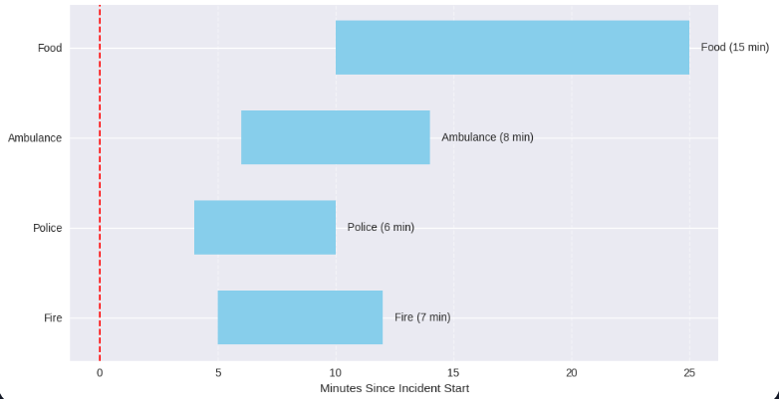
- Separate welcome page na may dashboard analytics din comparing each scenario from each other
  - Requests by category - shows volume trends across scenarios
    - Stacked bar chart - across scenarios
      - Each stack is by category - fire truck, police, ambulance
      - Default scenarios is the past 5 scenarios logged in. add option to select scenarios to show in the chart
      - 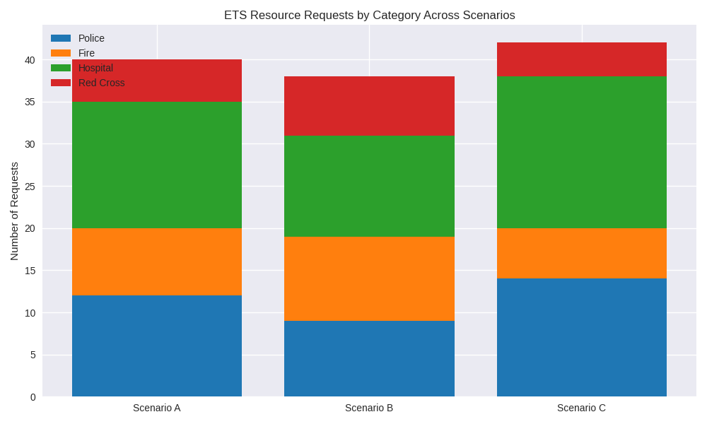
    - Response time lag per resource
      - Default scenarios is the past 5 scenarios logged in. add option to select scenarios to show in the chart
      - 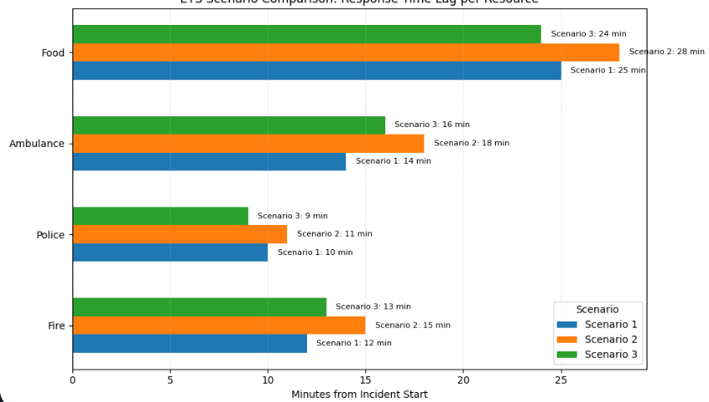
- Exported pdf
  - Should show the overall timeline
    - Currently, it only shows yung requested time sa left in chronological order
    - Ideally, it should also show yung time arrived in chronological order wherever it fits doon sa original requested time table
      - For example:
        - Originally:
          - 1:12 PM - Firetruck requested | done by: 1:20PM
          - 1:13 PM - Ambulance requested| done by: 1:30PM
          - 1:35 PM - 100 Food pax requested | done by 1:40 PM
        - How it should be
          - 1:12 PM - Firetruck requested
          - 1:13 PM - Ambulance requested
          - 1:20 PM - Firetruck arrived
          - 1:30 PM - Ambulance arrived
          - 1:35 PM - 100 Food pax requested
          - 1:40 PM - 100 Food pax arrived

November 18, 2025 version - comments
- Floating yung summary na tab sa gilid
- Import ng resources into
  - Saved a resource set on another laptop
  - Tried downloading the folder into another laptop, but the resource set was not saved
- Still need to fix the exported pdf
  - 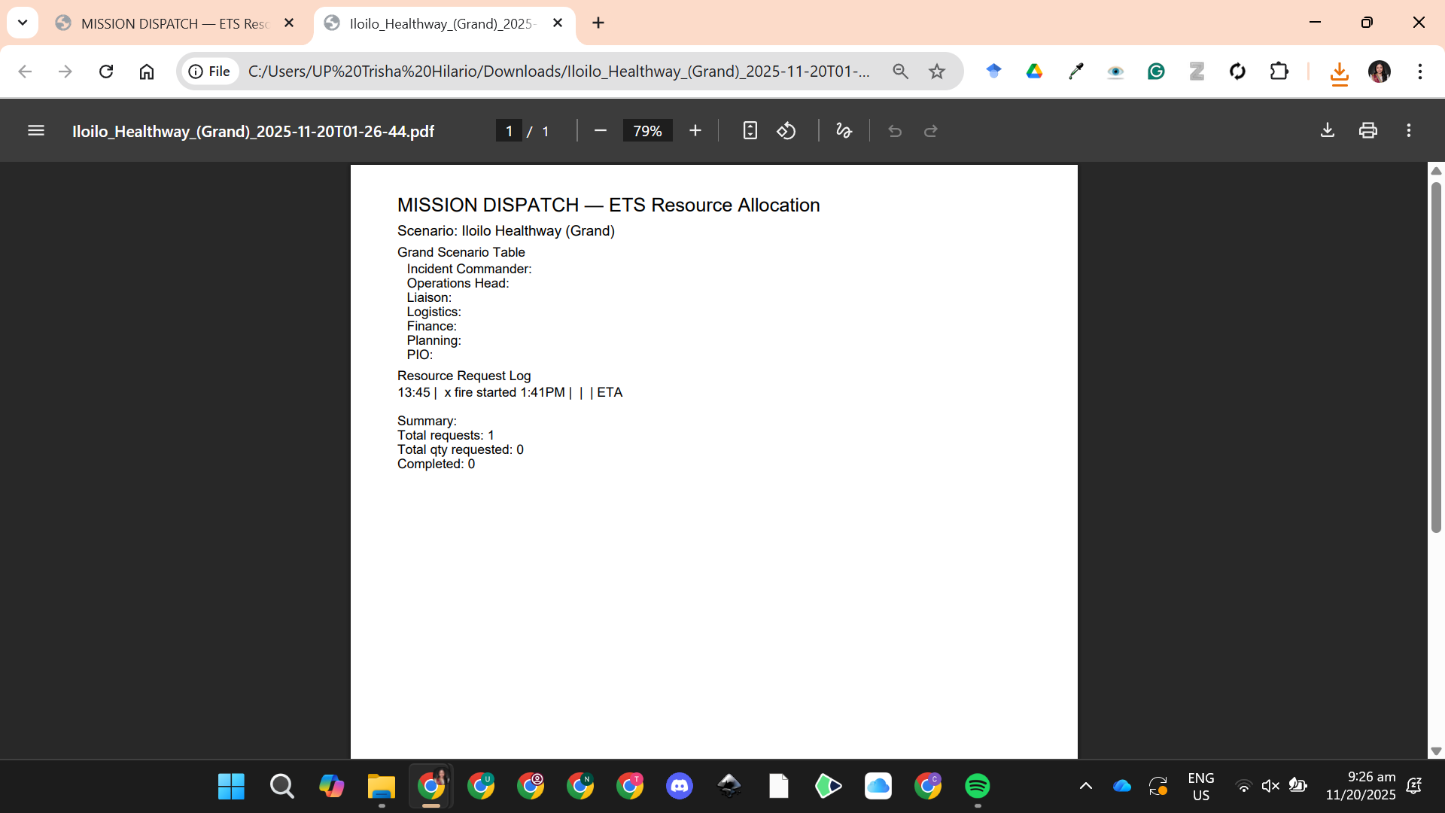

November 26 comments
- Paliitin yung gap between the role and assignment column
  - Pwede ba lagyan ng placeholder yung mga text boxes under the assignment for the user to know na pwede mag type in doon sa column ng assignment?
- Kailangan ng indicator sa mga inputs
- Tanggalin na yung “Grand” sa taas at yung “Grand Scenario Table”
  - Grand scenario table to “Incident Command Post Team”

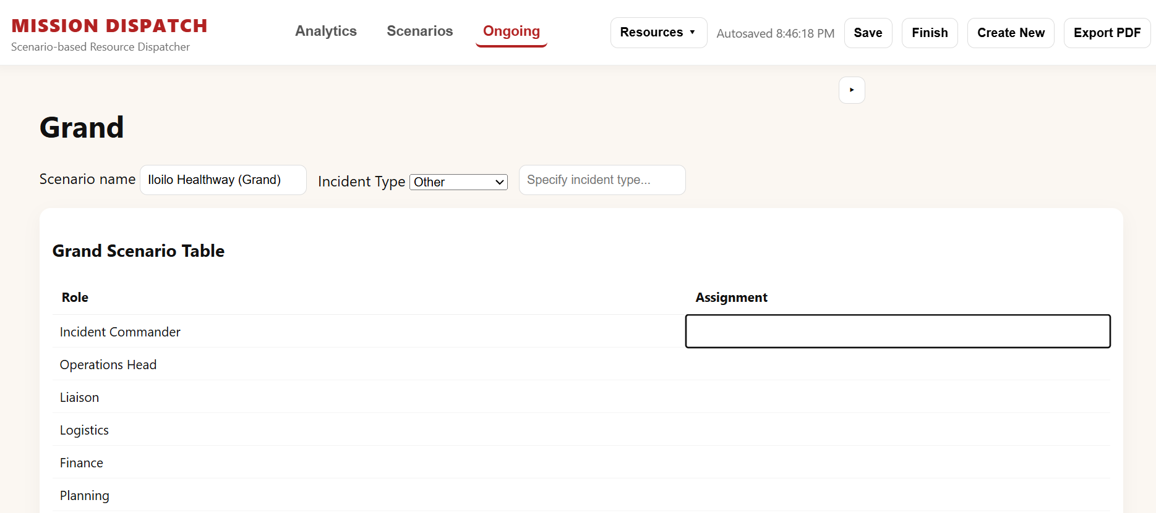
- Can we make the line per row thicker or darker? Kasi medyo nakakalito yung partitions?
  - 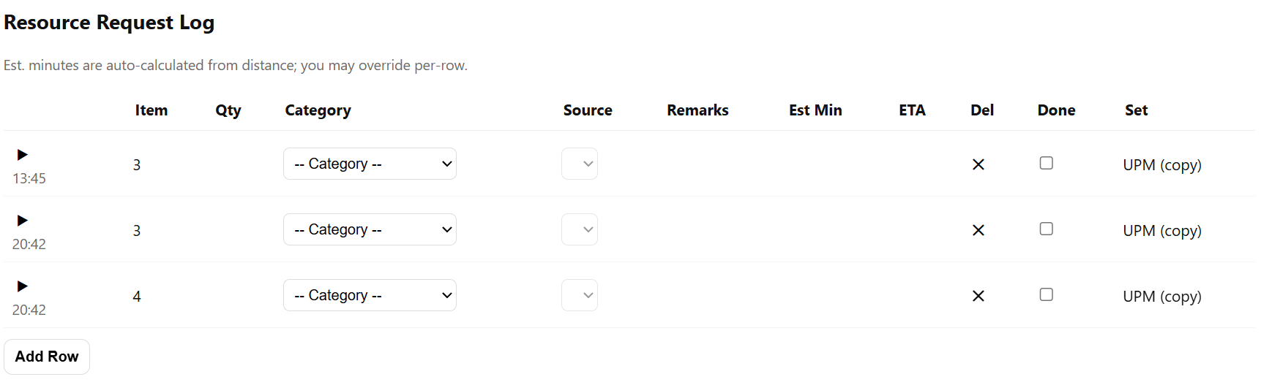
- Can we revise this part ng buttons sa “Analytics, Scenarios, and Ongoing”? Kasi it moves to the left side when clicking the ongoing so medyo nakakalito?
  - 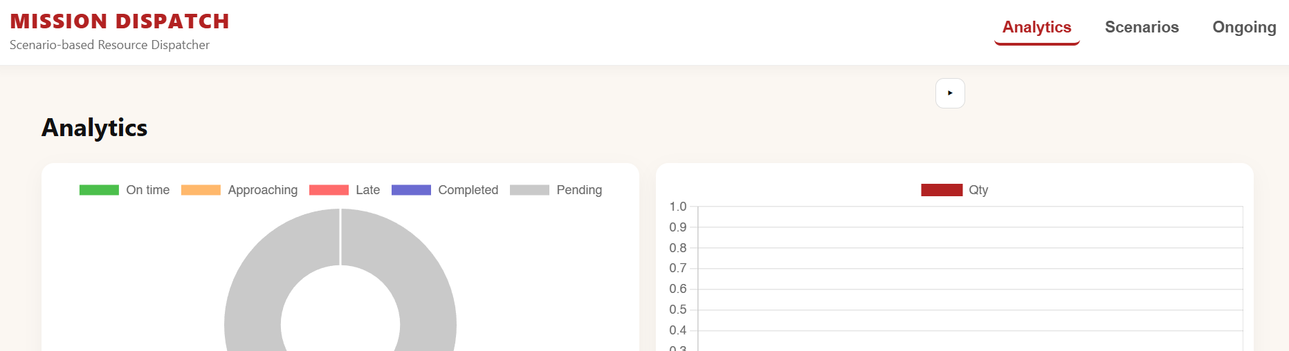
  - 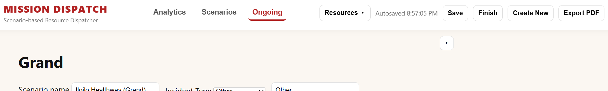
  - Fixed na lang yung “Analytics”, “Scenarios”, and “Ongoing” sa right at sila na lang ang nasa ribbon sa taas
  - Yung “Resources” Autosaved, “Save, “Finish, “create new, at “export pdf ay sa baba na under the ongoing na page since doon lag namana nag ffunction yung buttons na yun
  - Real-time analytics

- Yung drop down sa per row can we change the button to this? 
- Malaki space ng dropdown icon sa item; palakihin na lang yung sa item na space at fixed na size at wrapped na ang text.
  - 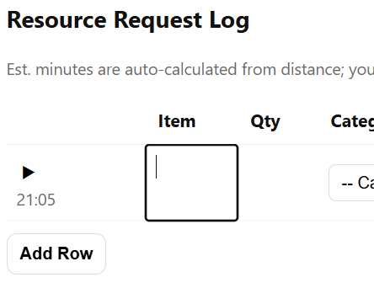
- Fixed na number lang pwede mainput sa qty, eta, at est mins. Currently pwede maginput ng text
  - 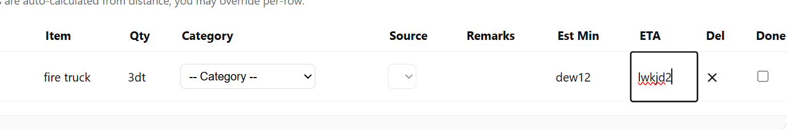
- Fixed na yung cells kasi nagaadjust siya based sa text. Better if nagwwrap na lang sa fixd na cell size. Currently lumalagpas yung entire row kapag mahaba nakasulat sa remarks
  - 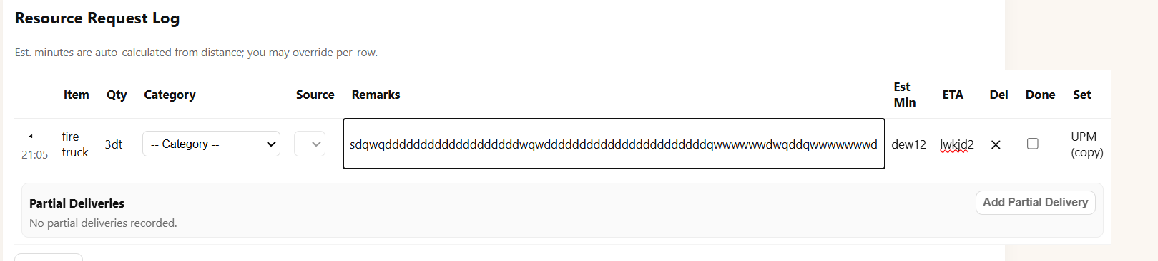
  - 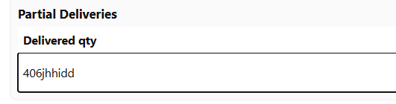
  - 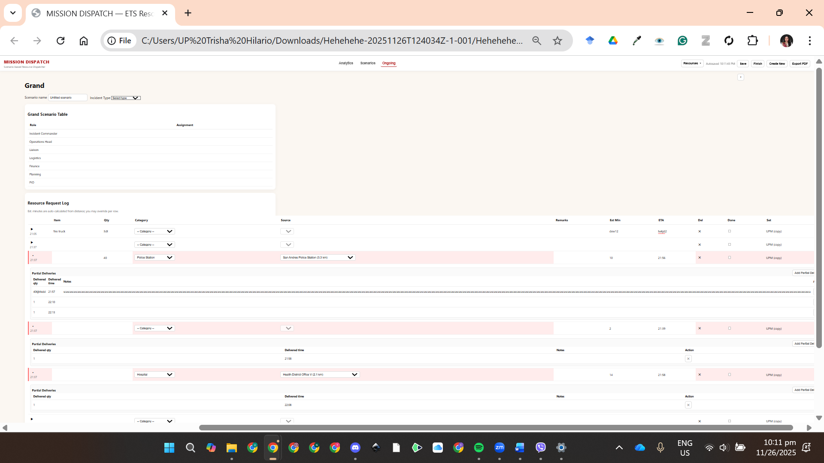
- Mahaba yug cell ng delivered time at qty. Longer sana yung sa notes instead
  - 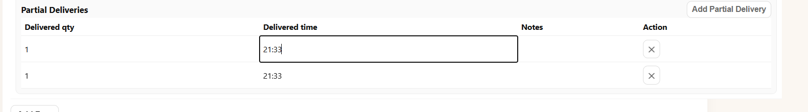
- Padagdag din ng source na function na dropdown sa partial deliveries kasi its possible na iba iba ang source per partial delivery
- Pachange ng “Est Min” header to “Est. (min.)”
- Make the headers, “Item, Qty, CAtegory, Source, etc.” sticky headers kasi mahirap mag refer to it kapag mahaba na masyado ang table
- Pagkapindot ng add row, may time na magappear kung kailang siya napindot, and upon selection ng category at source, may mag appear na est min at ETA. And, yung ETA ay nakabase sa current time ng system. For example:
  - 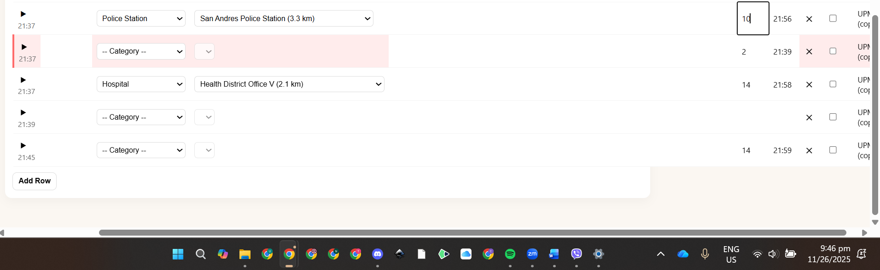
  - Nag add row ako at 21:37 (the first one), then the est mins at that time 4 mins so ang ETA niya ay 21:41. Tapos as we go on sa scenario, lets say nagchange ang est mins kasi may delays, so I tried changing the est mins to 10, and yung ETA niya ay naging 21:56 which is 10 mins after 21:46 (current system time), rather than doon sa initial na 21:37 on when the request was made. Confusing siya over time kasi yung nasa same row ay 21:37 but when you add the inpute est mins na 10 ay hindi siya nag aadd up doon sa ETA which should be 21:47.
- Can we add sa first row parang row na “Start of Incident” tapos mallog in din yung time? Pati sa “End of Incident” sa dulo. Pwede kasi magstart yung incident pero wala pa muna request ng resources
  - Beside the resource request log
  - Start of incident:
  - End of incident:
- On saving resource set, put header or parang placeholder sa text box na “Name of station” and “Distance (km)” para may reference
  - 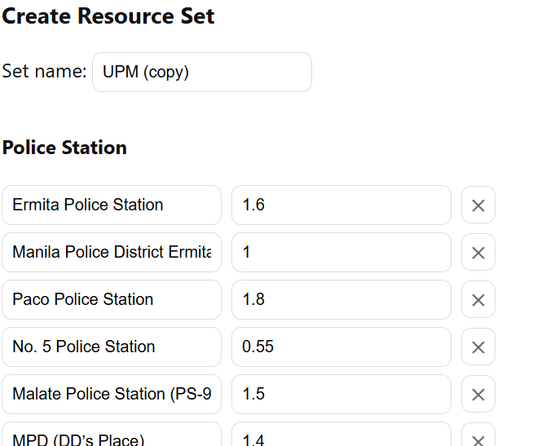

- Pwede pa kaya ma view and edit yung resource sets?
  - 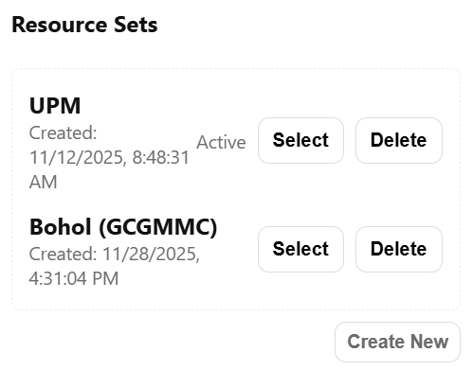
- Fix this part:
  - 